# **Importing modules**

import pandas as pd

import numpy as np

import matplotlib.pyplot as plt

from sklearn.model_selection import train_test_split

from sklearn.linear_model import LinearRegression

from sklearn.metrics import mean_squared_error,mean_absolute_error

from sklearn.ensemble import RandomForestRegressorv

# **Reading the Dataset**

df=pd.read_csv("D:\\miniproject\\stocks.csv")

df

**output:**

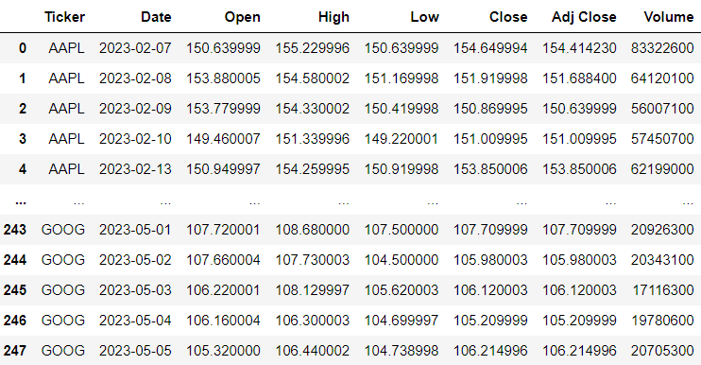

# **Dropping the unwanted column**

df.drop(['Ticker','Adj Close'],axis=1,inplace=True)

df

**output:**

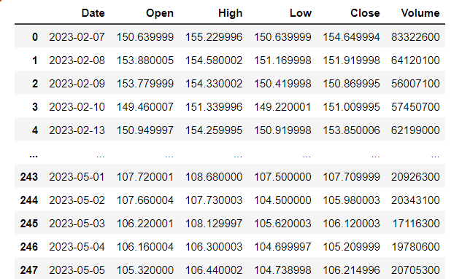

# **Data checks to perform**

**#To check first five columns**

df.head()

**#To check last five columns**

df.tail()

**#checking missing values**

df.isnull().sum() **or** df.isnull().any()

**output:**

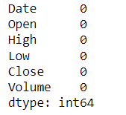**or** 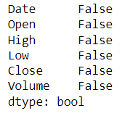

**#checking information about dataset**

df.info()

**output:**

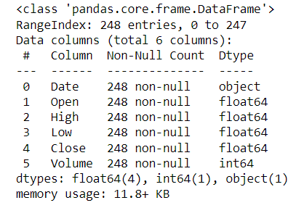

**#check statistics of dataset**

df.describe()

**output:**

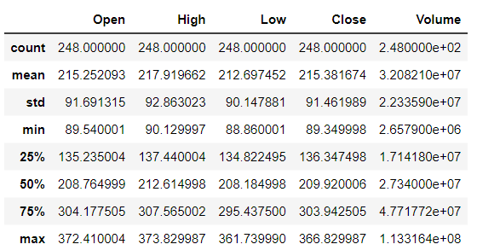

print('length of dataset:',len(df))

print('shape of the dataset',df.shape)

print("Number of columns in the dataset:",df.columns)

**output:**

lenghth of dataset: 248

shape of the dataset (248, 6)

Number of columns in the dataset: Index(['Date', 'Open', 'High', 'Low', 'Close', 'Volume']

# Explorartory data analysis

**#**

df['Open'].plot(figsize=(16,6))

plt.title('Linechart')

plt.xlabel('Open')

plt.ylabel('frequency')

plt.show()

**output:**

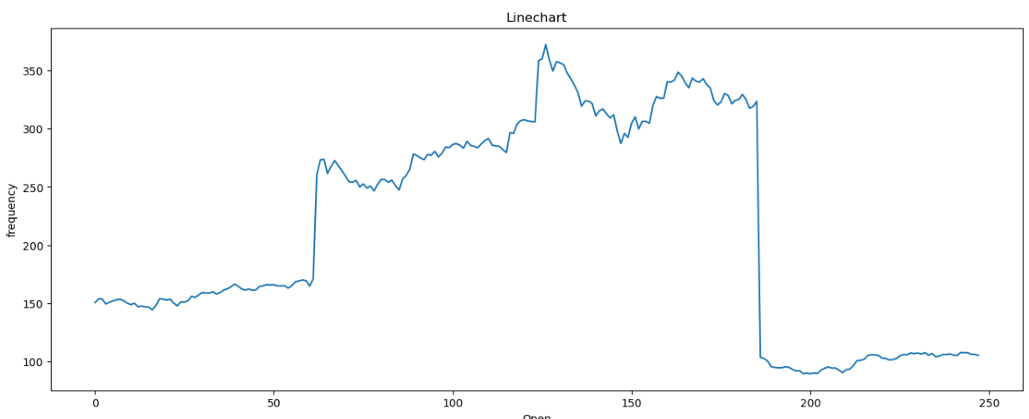

**Summary:_____________________________________________________________________________________________________________________________________________________________________________________________________________________________________________**

**__________________________________________________________________________________**

# Data preprocessing

**#splitting the date column into year,month,day**

x=df

x['year']=pd.DatetimeIndex(x['Date']).year

x['month']=pd.DatetimeIndex(x['Date']).month

x['day']=pd.DatetimeIndex(x['Date']).day

x

**output:**

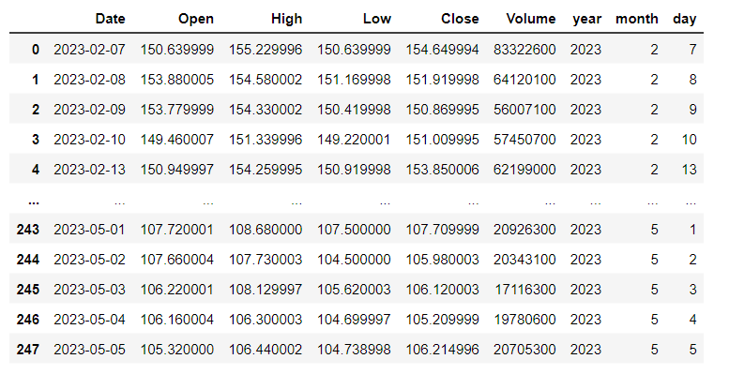

# Training the model for MultipleLinearRegression

**#splitting the dataset**

x=df.drop(['Close','Date'],axis=1)

y=df['Close']

x_train,x_test,y_train,y_test=train_test_split(x,y,random_state=0)

print('xtrain:',x_train.shape)

print('xtest:',x_test.shape)

print('ytain:',y_train.shape)

print('ytest:',y_test.shape)

**output:**

xtrain: (186, 7)

xtest: (62, 7)

ytain: (186,)

ytest: (62,)

**#model training**

regressor=LinearRegression()

regressor.fit(x_train,y_train)

**output:**

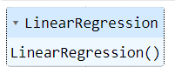

**#To check intercept and co-efficient**

print('intercept:',regressor.intercept_)

print('Co-efficient:',regressor.coef_)

**output:**

intercept: -0.6115052912800536

Co-efficient: [-5.45434461e-01 7.34498290e-01 8.12746520e-01 4.09319930e-096.34908792e-16 1.03687704e-01 1.15818167e-03]

**#Predictions**

y_pred=regressor.predict(x_test)

y_pred

**output:**

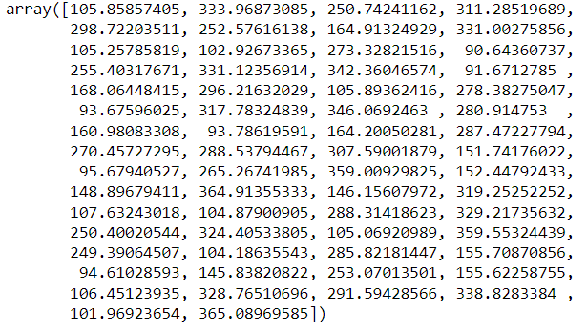

**#Evaluating the model**

train_accuracy=regressor.score(x_train,y_train)

print('train_accuracy(R_Squared):',train_accuracy)

test_accuracy=regressor.score(x_test,y_test)

print('test_accuracy(R_Squared):',test_accuracy)

print('Mean Absolute Error:',metrics.mean_absolute_error(y_test,y_pred))

print('Mean Squared Error:',metrics.mean_squared_error(y_test,y_pred))

print('Root Mean Squared Error:',math.sqrt(metrics.mean_squared_error(y_test,y_pred)))

**output:**

train_accuracy(R_Squared): 0.9996274457101879

test_accuracy(R_Squared): 0.9996351890659423

Mean Absolute Error: 1.3038307748950013

Mean Squared Error: 3.3155240230458447

Root Mean Squared Error: 1.8208580458250567

**#To check actual price ,predicted price and difffrence**

dfr=pd.DataFrame({'Actual Price':y_test,'Predicted Pric:y_pred,'Diffrence':y_test-y_pred})

dfr

**output:**

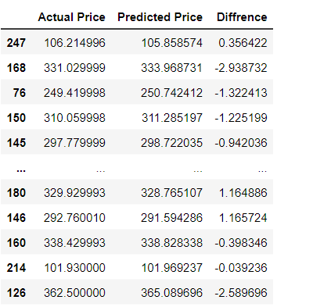

**#Plotting the bar graph to check difference between actual price and predicted price**

graph=dfr.head(20)

graph.plot(kind='bar')

plt.title('BarGraph')

plt.xlabel('Actual&prediceted price')

plt.ylabel('frequency')

plt.show()

**output:**

**summary:________________________________________________________________________________________________________________________________________________________________________________________________________________________________________________________________________________________________________________________________**

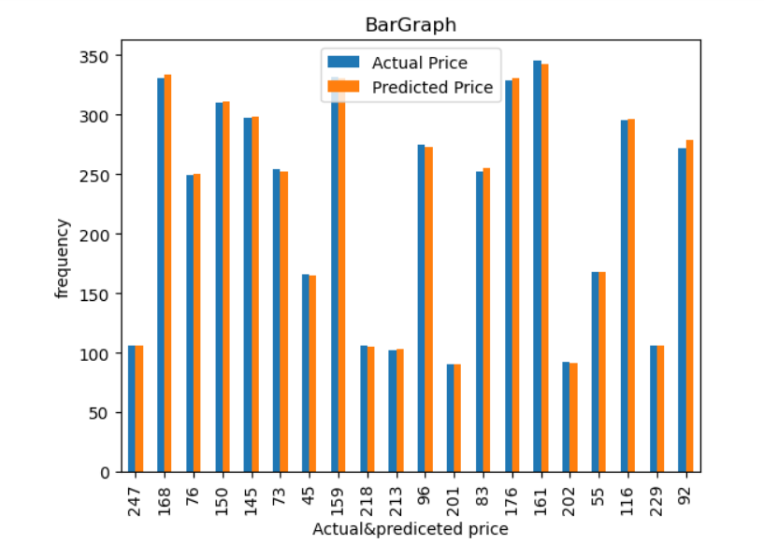

# Training the model for RandomForestRegressor

**#model training**

from sklearn.ensemble import RandomForestRegressor

regressor = RandomForestRegressor(n_estimators=100,random_state=0)

regressor.fit(x_train,y_train)

**output:**

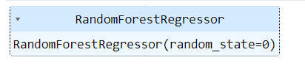

**#Evaluating the model**

train_accuracy=regressor.score(x_train,y_train)

print('train_accuracy(R_Squared):',train_accuracy)

test_accuracy=regressor.score(x_test,y_test)

print('test_accuracy(R_squared):',test_accuracy)

**output:**

train_accuracy(R_Squared): 0.9998571271849735

test_accuracy(R_squared): 0.9987098858585105

**#Comparision between Linear and RandomForestRegression using barplot**

linear_regression_accuracy =0.9995657233927607

random_forest_accuracy =0.9987098858585105

accuracy_scores = [linear_regression_accuracy, random_forest_accuracy]

model_names = ['Linear Regression', 'Random Forest Regression']

plt.bar(model_names, accuracy_scores)

plt.xlabel('Regression Models')

plt.ylabel('Test Accuracy')

plt.title('Comparison of Test Accuracy: Linear Regression vs Random Forest Regression')

plt.show()

**output:**

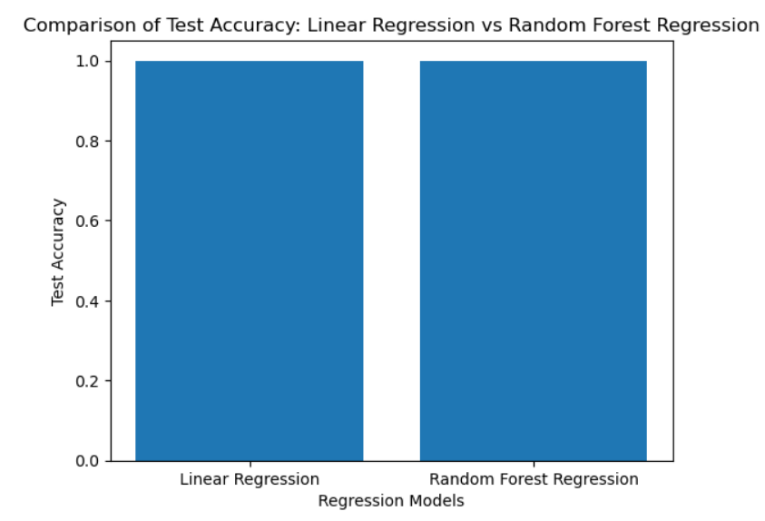

**Summary:**